# Lesson 2 Bluetooth Car

## Points of this section

It is very important and so cool to control your car wirelessly in a certain space

when we learn the Arduino, so in the lesson, we will teach you how to control

a car by Bluetooth.

Learning Parts:

Learn how to use the Bluetooth module and the Bluetooth APP

1

Learn how to control the vehicle via Bluetooth

Write programs to implement this function

Preparations:

A vehicle (equipped with battery)

A USB cable

A Bluetooth module

An IPhone or tablet

## ****Ⅰ****. Bluetooth module

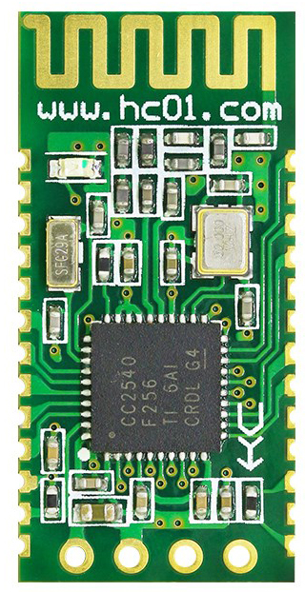

### The description of Bluetooth module:

1. Adopt mainstream Bluetooth chip of TI, protocol standard of Bluetooth V4.0.

2. Analog working voltage of serial port is 3.3V.

3. Users can set baud rate 1200, 2400, 4800, 9600, 19200, 38400, 57600,115200.

4. Dimension of key module is 28mm x 15 mm x 2.35mm.

5. Working electric current: 40MA.

6. Dormancy electric current: less than 1MA.

7. Being used for GPS navigation system, hydroelectric gas reading system, industrial field mining control system.

8. Can be connected to Bluetooth laptop, computer with Bluetooth adapter, PDA, etc.

### This is the schematic diagram of Bluetooth module connected to UNO controller board:

In the experiment we will connect it to UNO board via expansion board V5.

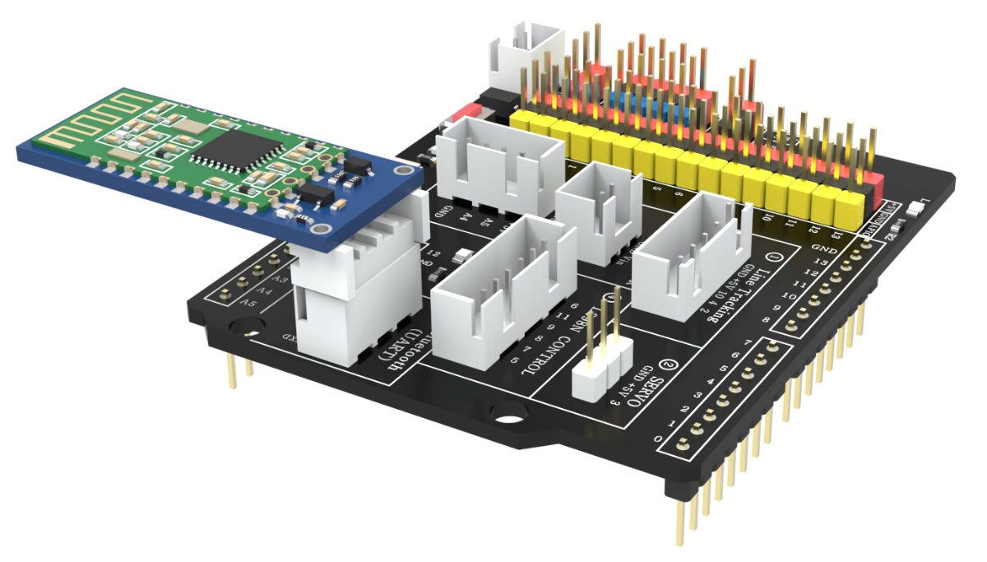

## ****Ⅱ. Getting Started with the**** Bluetooth APP

Before you start, please remove the Bluetooth module, find the path to the Bluetooth cart program, open the program, make sure that the development board and the port are Arduino UNO, then click on the upload button to upload the program, and after the upload is successful, connect the Bluetooth module back.

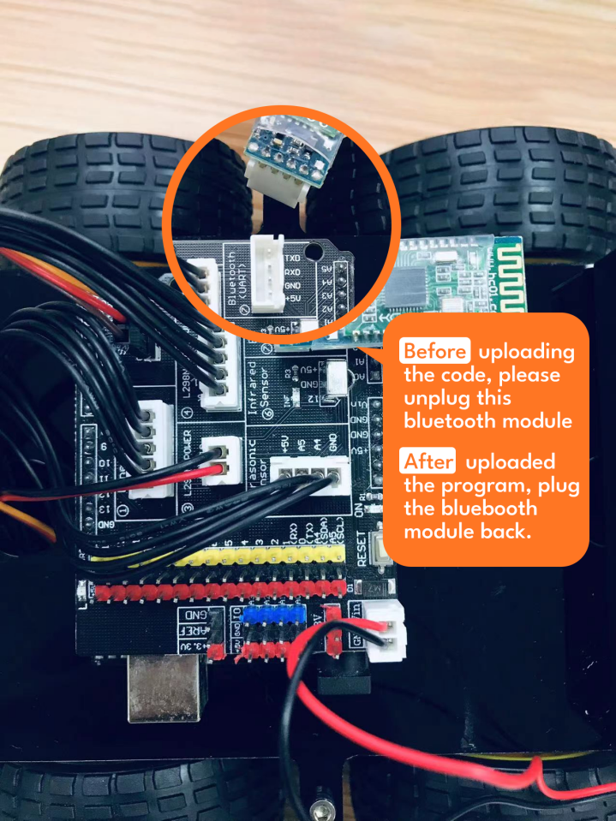

Find the Bluetooth cart program path

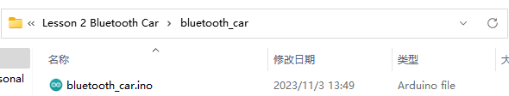

Open the program and make sure the development board and ports are Arduino UNO

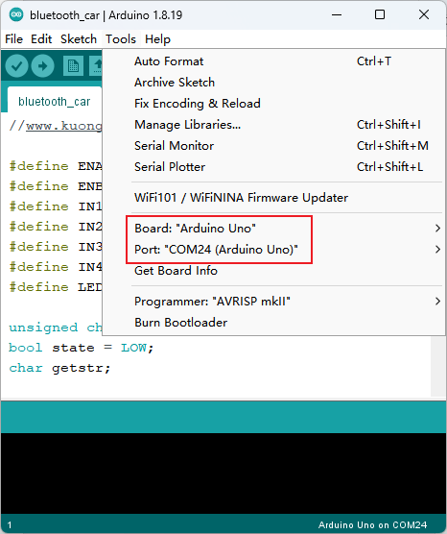

Click the Upload button



Just wait for the upload to be successful

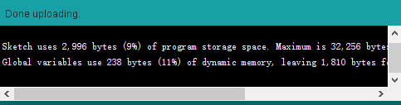

### STEP1: Install the application.

**For Android**

**Just open the companion CD or profile, copy the APK file in the folder to your Android phone, and install it later.（Or send it to your cell phone via communication software）**



**If your computer doesn't support CD-ROM drive and can't read the information inside the CD-ROM, please contact our customer service staff and we will send you the information package or information link separately.**

After the installation is complete, the following icon will appear on your phone:



**For Apple system:**

**Enter kuongshun in the App Store search bar and click on Get to download and install!**

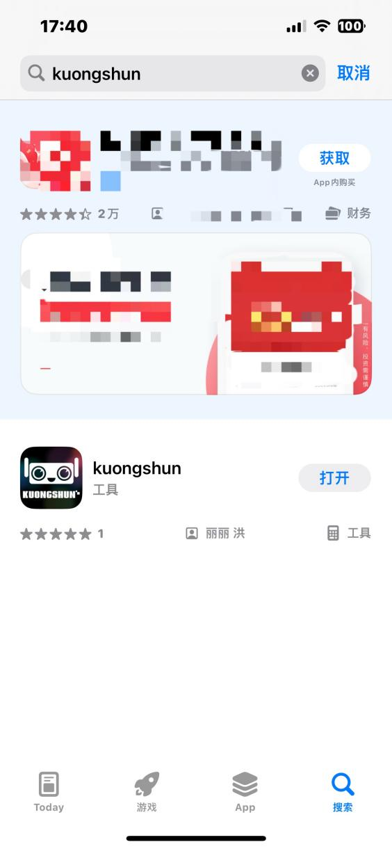

**After the installation is complete, the following icon will appear on your phone:**



### STEP2: Software operation.

Turn on the Bluetooth function of your cell phone and turn on the car power switch of the cart, the expansion board will light up and the Bluetooth module will blink.

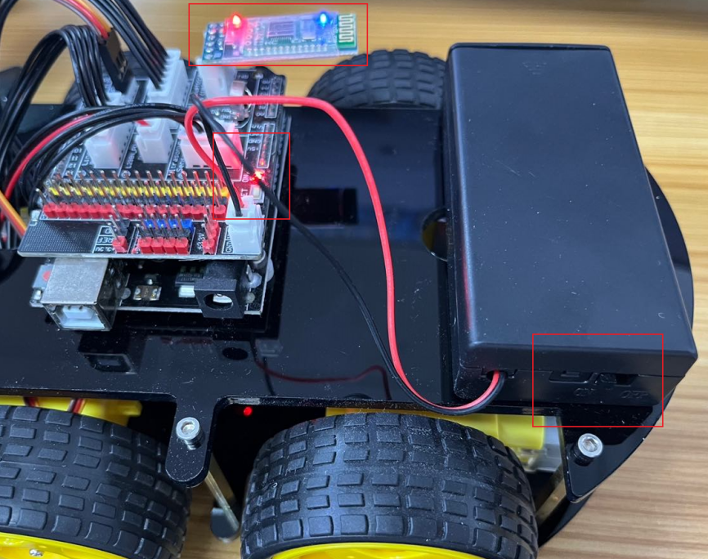

**Open the kuongshun software and select Smartbot**

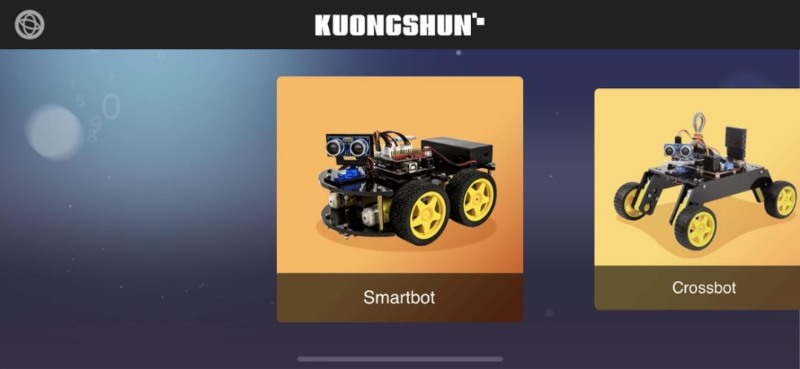

**Select joystick control**

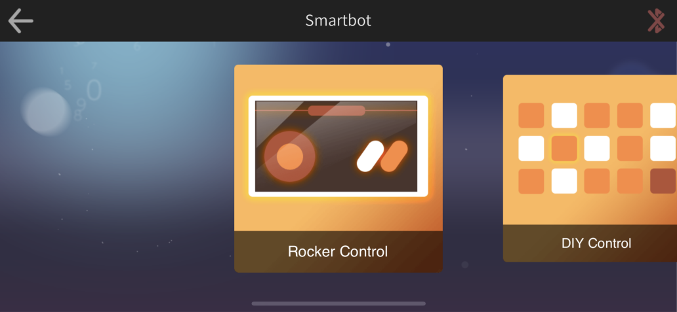

**After opening the interface as follows, operate any button**

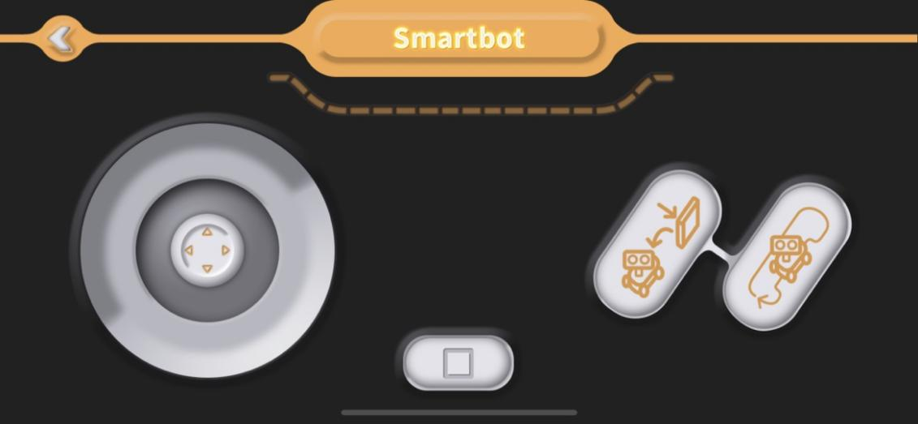

**A selection box will appear as shown below, select OK**

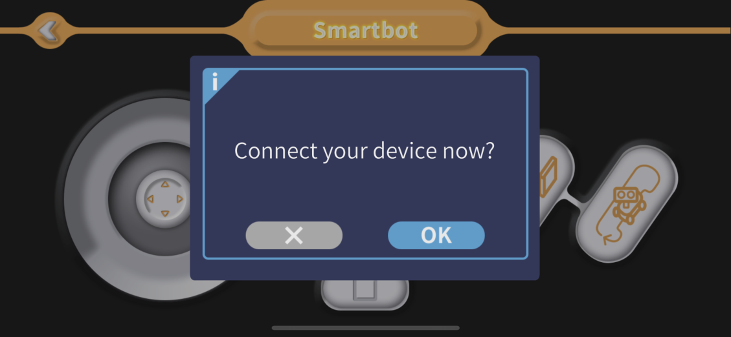

**An animation will appear**

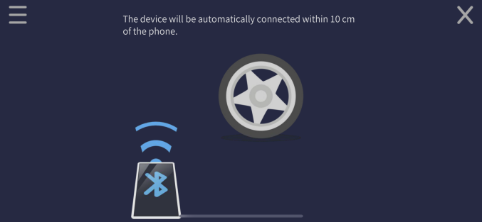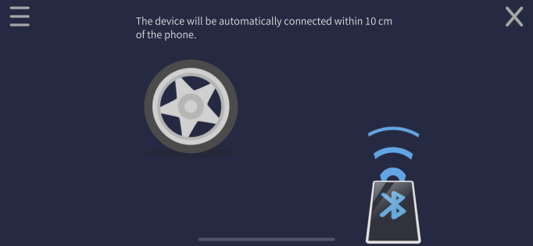

**Put the cell phone close to the car when the car Bluetooth module stops blinking to stay lit, that is, the connection is successful** (if the connection fails, please power off and restart the car)

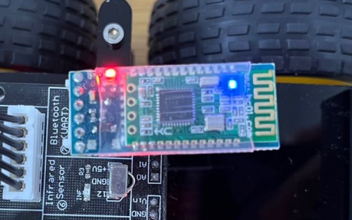

**Now you can drive the cart as much as you want!**

**Page Introduction：**

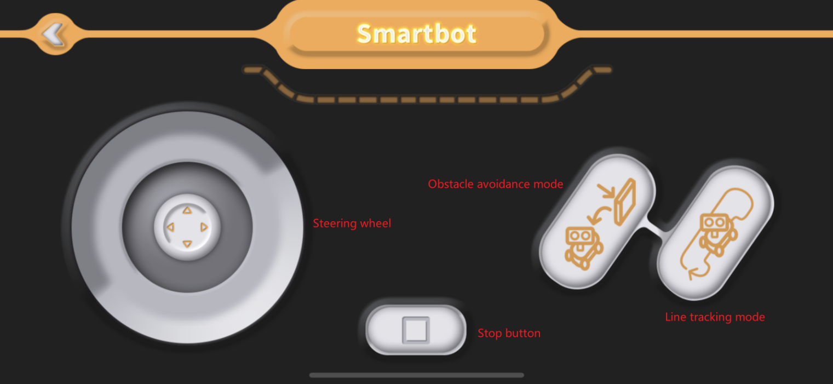

**When the steering wheel is slid upward, the cart moves forward**

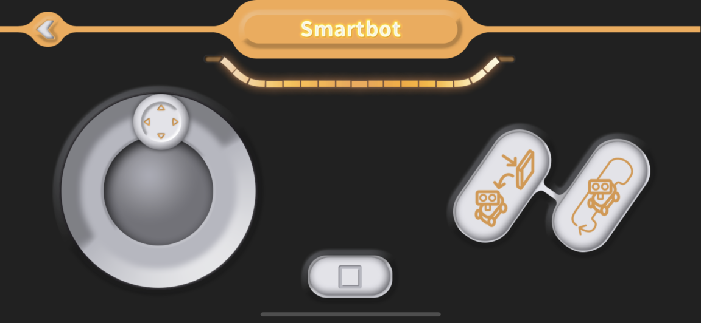

**When the steering wheel slides down, the cart will back up**

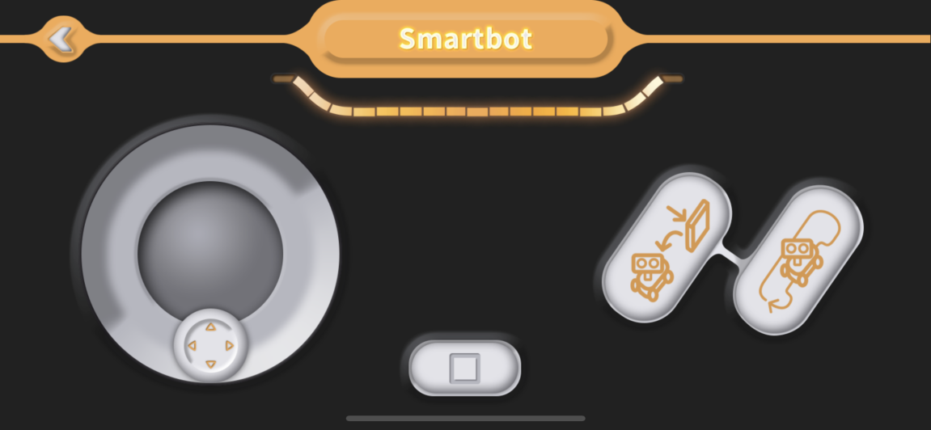

**When the steering wheel is slid to the left, the cart will turn left**

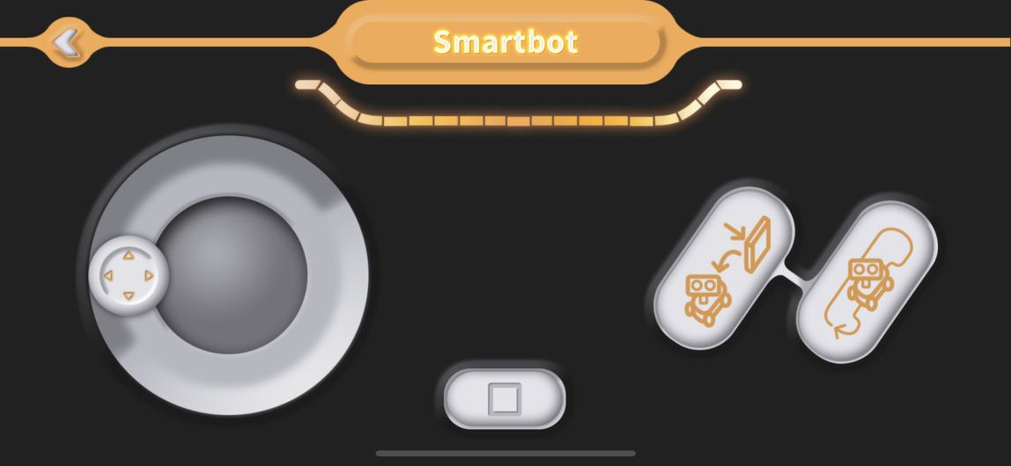

**When the steering wheel slides to the right, the cart will turn right**

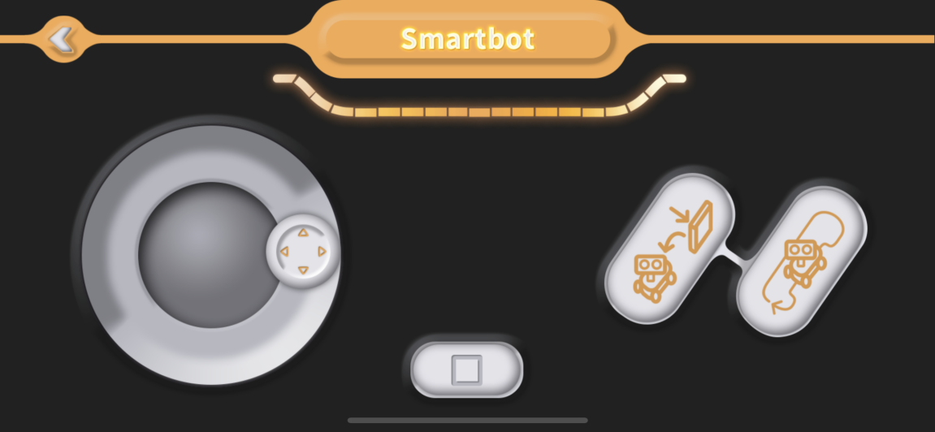

**The cart will stop when the steering wheel is released.**

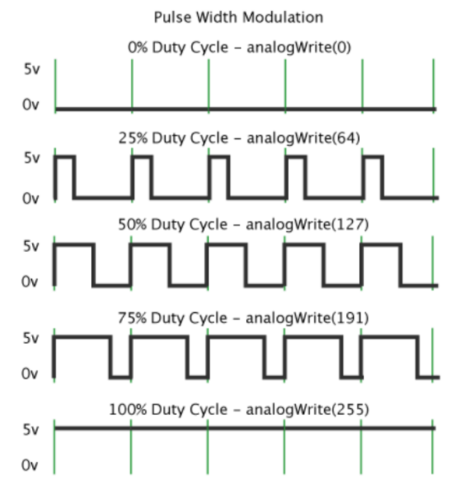**The stop button stops the cart, obstacle avoidance mode and line patrol mode will be added later.**

## ****Ⅲ.**** Make a Bluetooth Car

When the car turns left or right, it’s not necessary to set the speed too fast. On the contrary, we need to control the speed of car. But how to control?

The answer is PWM.

PWM is the abbreviation of “Pulse Width Modulation”, is called pulse modulation in short, is an effective technology to control analog circuit with digital output of microprocessor, car is used to change speed of motor by altering duty cycle of a square wave. In other words, connect and break circuit between two sides of motor constantly, is switch of holding motor work, motor will not be off when power is off because of the fast speed. So we can control speed of car if we control specific value of power on time and power off time. The speed of car will be max when circuit is holding still. The speed of car will be minimum if circuit is holding off. The speed of car will be median in half time. PWM is a technology to get analog quantity through digital method. A square wave is formed by digital control, square wave signal only have two state of on and off (That is high-low of digital pins). Simulate voltage changing from 0 to 5V by controlling specific value of duration on and off time. Occupied time of on (That is high level in academy) is called pulse width, so PWM is also called pulse width modulation. Let’s learn about PWM through five square waves below.

Green vertical line above represent a period of square wave. The value written into every analogWrite(pin,value) corresponds to the percentage, the percentage is also called Duty Cycle, refer to the percentage gotten from specific value between duration high level and low level time in a period. In figure, from top to bottom, the first square wave, duty cycle is 0%, corresponding value is 0. Output circuit current is minimum, motor hold still. The longer duration time is, the bigger circuit current motor gets, the faster the speed is. So, the final one’s duty cycle is 100%, corresponding value is 255, motor rotates in full speed. 50% is medium hyponastic rotate speed, 25% is relatively slower, even can’t start (The circuit current is relatively big to start motor because of static friction). PWM is mostly used to adjust light of LED and rotate speed of motor, wheel speed controlled by motor is easily be controlled. The advantage of PWM can be more reflected when you play with some Arduino cars.

analogWrite(pin, value)；

analogWrite() is used to write analog value of 0 to 255 for PWM ports. What you need to note is that, analogWrite() is only used to digital pins with function of PWM. Pins with function of PWM in UNO are only digital pins of 3，5，6，9，10，11.

Our car’s speed is controlled by connecting pin5 and pin6 of ENA and ENB. The program below, have set a digital function int carSpeed = 150;

The speed is controlled in below program, so you can control the speed on your own.

analogWrite(ENA, carSpeed);

analogWrite(ENB, carSpeed);

After learning the basic knowledge, we will upload the program as below to the car, open the code file in the path “\Kuongshun Smart Robot Car Kit V3.0\bluetooth_car\ bluetooth_car.ino” and then upload the program to the UNO control board.

**Code preview:**

*//www.kuongshun.com*

#define ENA 5

#define ENB 6

#define IN1 7

#define IN2 8

#define IN3 9

#define IN4 11

#define LED 13

unsigned char carSpeed = 200;

bool state = LOW;

char getstr;

void forward(){

  digitalWrite(ENA,HIGH);

  digitalWrite(ENB,HIGH);

  digitalWrite(IN1,HIGH);

  digitalWrite(IN2,LOW);

  digitalWrite(IN3,LOW);

  digitalWrite(IN4,HIGH);

  Serial.println("Forward");

}

void back(){

  digitalWrite(ENA,HIGH);

  digitalWrite(ENB,HIGH);

  digitalWrite(IN1,LOW);

  digitalWrite(IN2,HIGH);

  digitalWrite(IN3,HIGH);

  digitalWrite(IN4,LOW);

  Serial.println("Back");

}

void left(){

  analogWrite(ENA,carSpeed);

  analogWrite(ENB,carSpeed);

  digitalWrite(IN1,LOW);

  digitalWrite(IN2,HIGH);

  digitalWrite(IN3,LOW);

  digitalWrite(IN4,HIGH);

  Serial.println("Left");

}

void right(){

  analogWrite(ENA,carSpeed);

  analogWrite(ENB,carSpeed);

  digitalWrite(IN1,HIGH);

  digitalWrite(IN2,LOW);

  digitalWrite(IN3,HIGH);

  digitalWrite(IN4,LOW);

  Serial.println("Right");

}

void stop(){

  digitalWrite(ENA,LOW);

  digitalWrite(ENB,LOW);

  Serial.println("Stop!");

}

void stateChange(){

  state = !state;

  digitalWrite(LED, state);

  Serial.println("Light");

}

void setup() {

  Serial.begin(9600);

  pinMode(LED, OUTPUT);

  pinMode(IN1,OUTPUT);

  pinMode(IN2,OUTPUT);

  pinMode(IN3,OUTPUT);

  pinMode(IN4,OUTPUT);

  pinMode(ENA,OUTPUT);

  pinMode(ENB,OUTPUT);

  stop();

}

void loop() {

  getstr = Serial.read();

  switch(getstr){

    case 'f': forward(); break;

    case 'b': back();   break;

    case 'l': left();   break;

    case 'r': right();  break;

    case 's': stop();   break;

    case 'a': stateChange(); break;

    default:  break;

  }

}

Switch on the power supply of the vehicle and put it on the ground. Now we can control the car by Bluetooth and play with it.